**How to Create A VPC with Public and Private Subnets AND IGW and Route Tables**

1-Login to the AWS Console

2- Go to VPC Section

3- Click on Create VPC

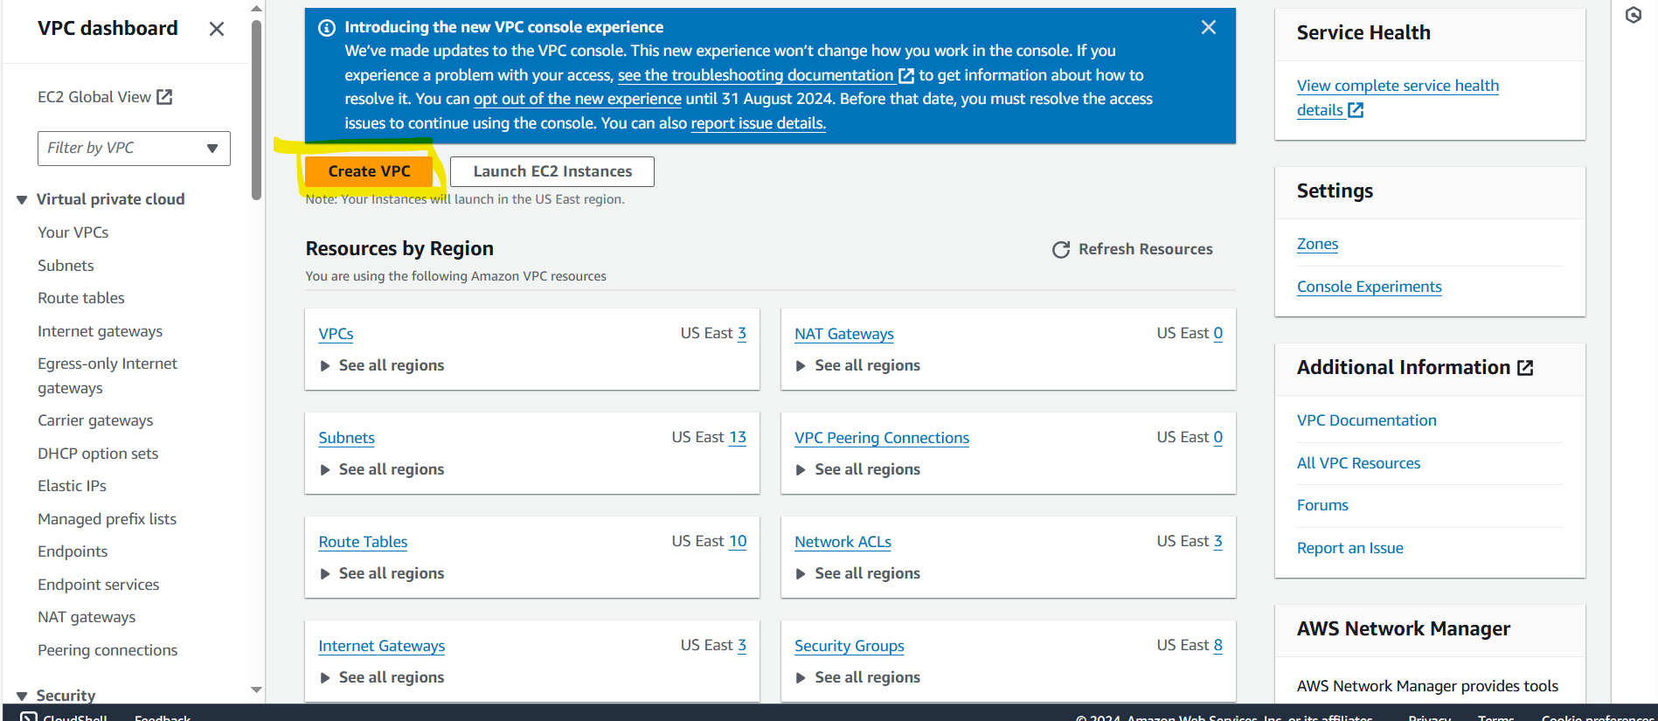

4-Give VPC Name and Give VPC CIDR Range 10.1.0.0/16

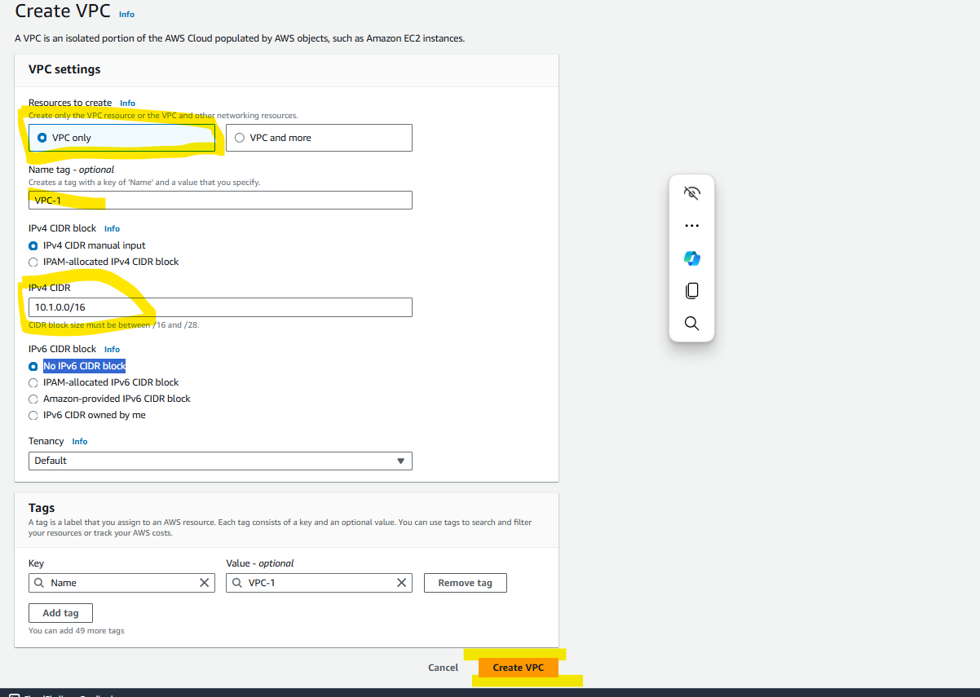

5-Click on Create VPC

6-Click On Actions in VPC

7-Select the Edit VPC settings

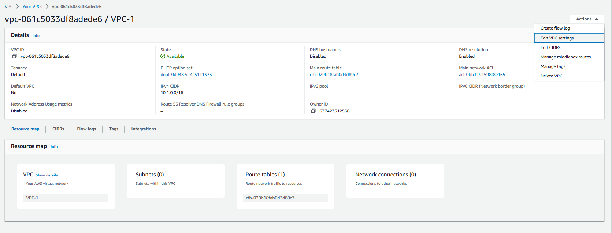

8-Check the Enable DNS Hostname

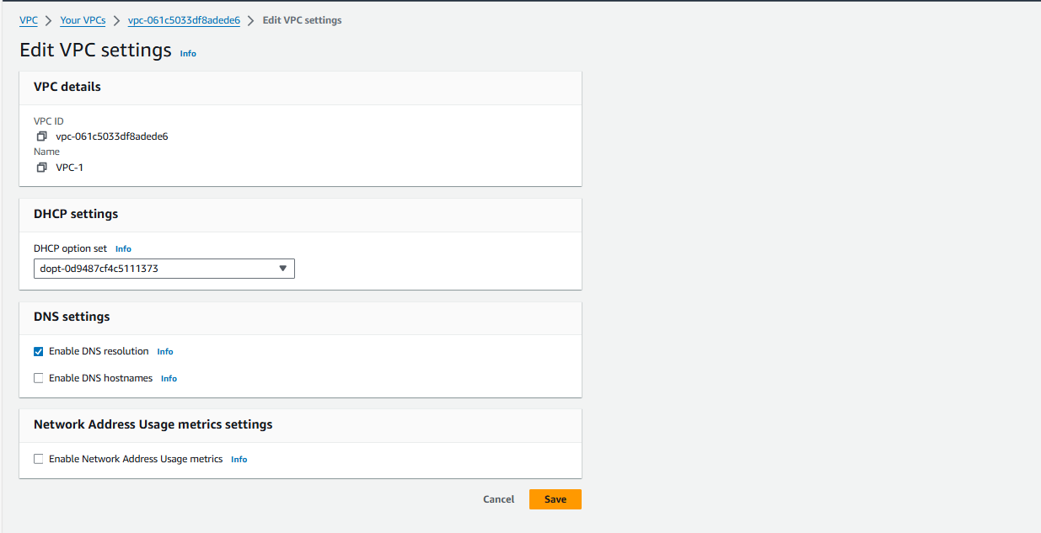

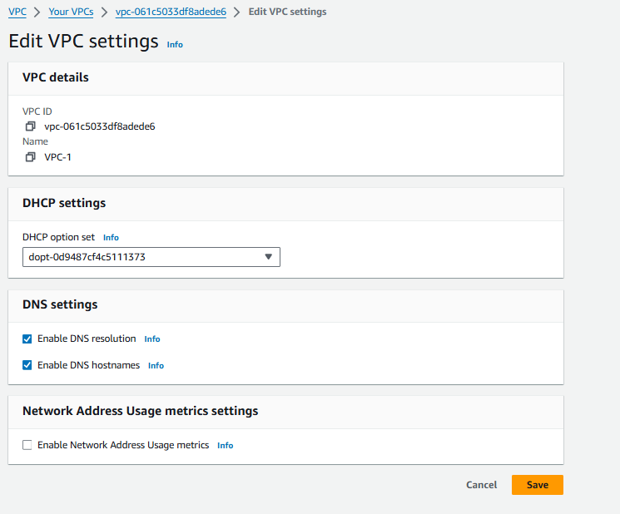

9-Click on Save

10-Click on Create Subnets

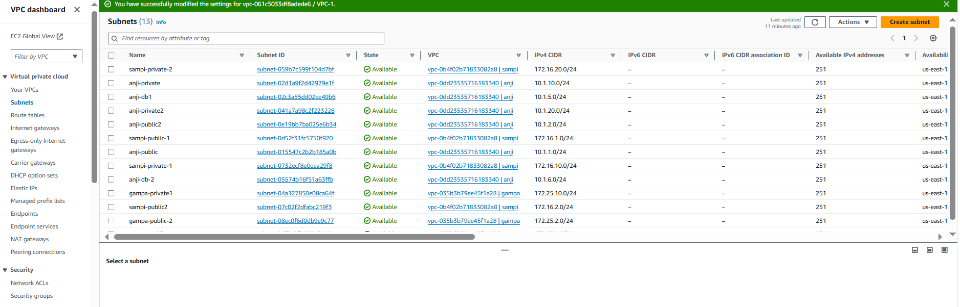

11-Select VPC

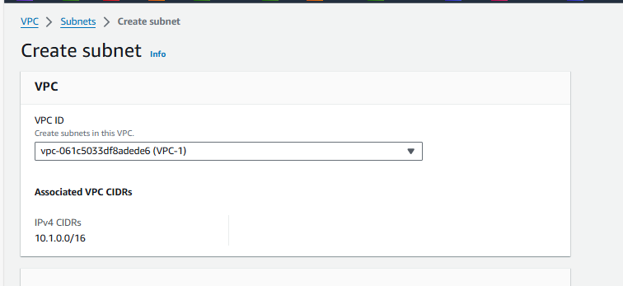

12-Give Subnet Name and IP range

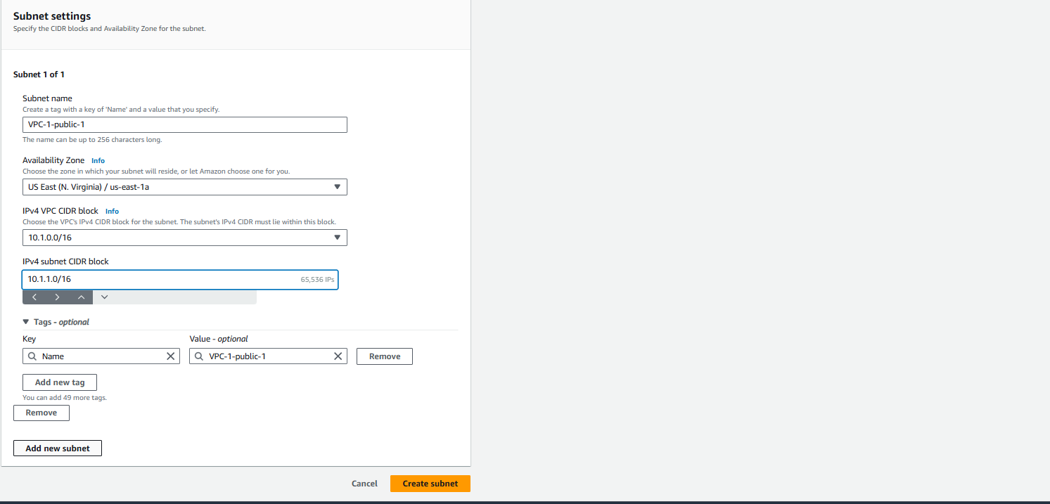

13-Like You can create how many you want I am, taking here 6 Subnets

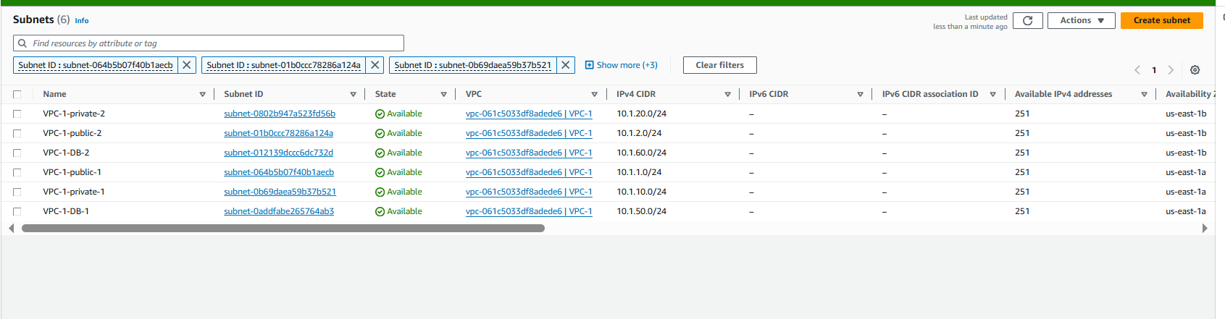

14-Click on Create Internet Gateway

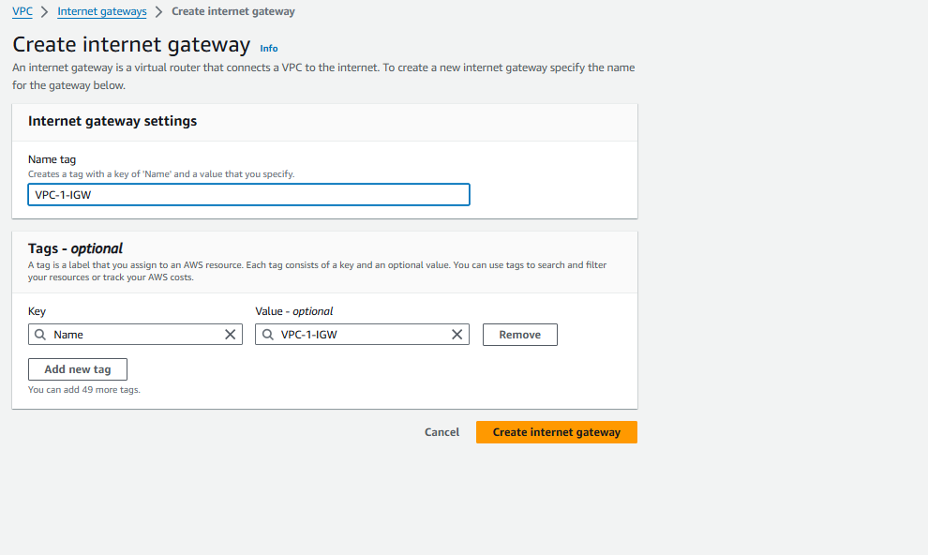

15-Attach the IGW to VPC

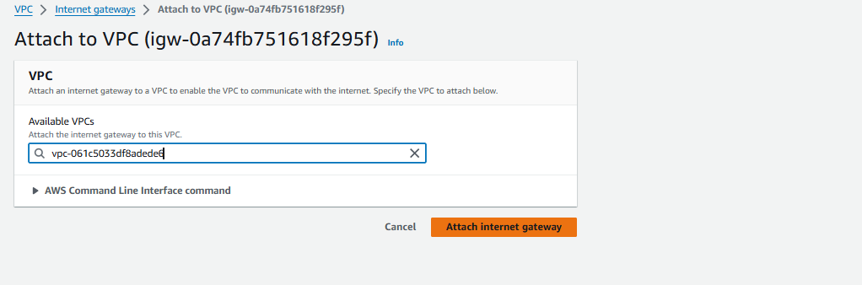

16-Click on Create Internet Gateway

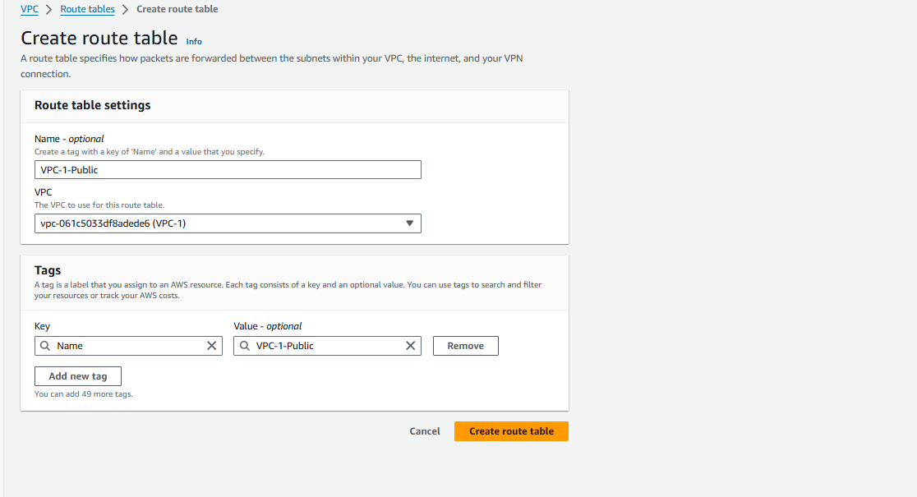

17-Here I am Taking 3 Route Tables VPC-1-Public and VPC-1-Private and VPC-1-DB

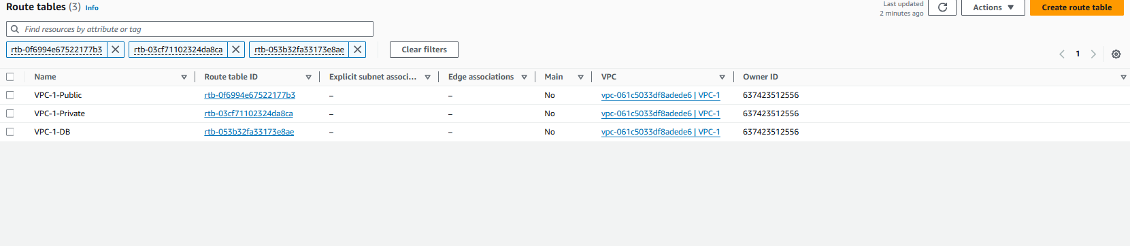

18-Click on VPC-1-Public click on Edit subnet associations

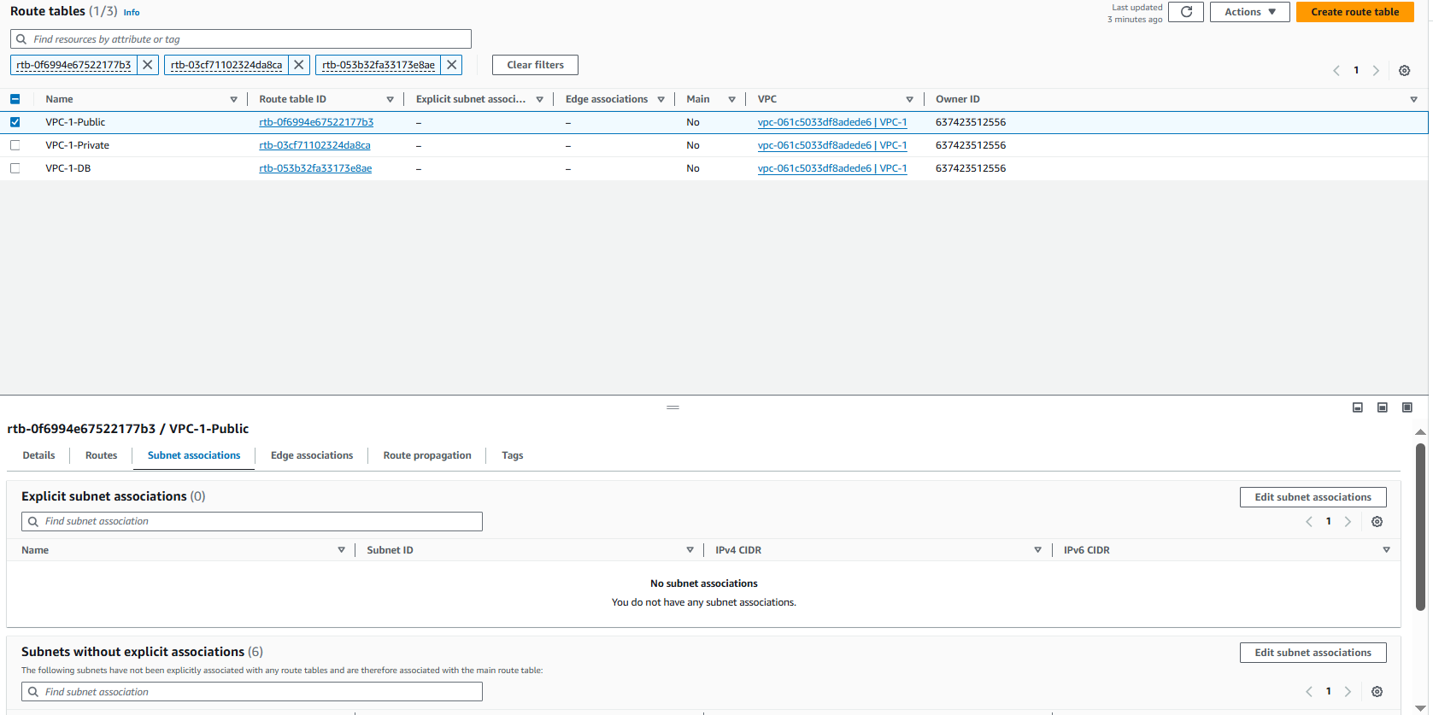

19-Add your public subnets VPC-1-public-1 and VPC-1-Public-2

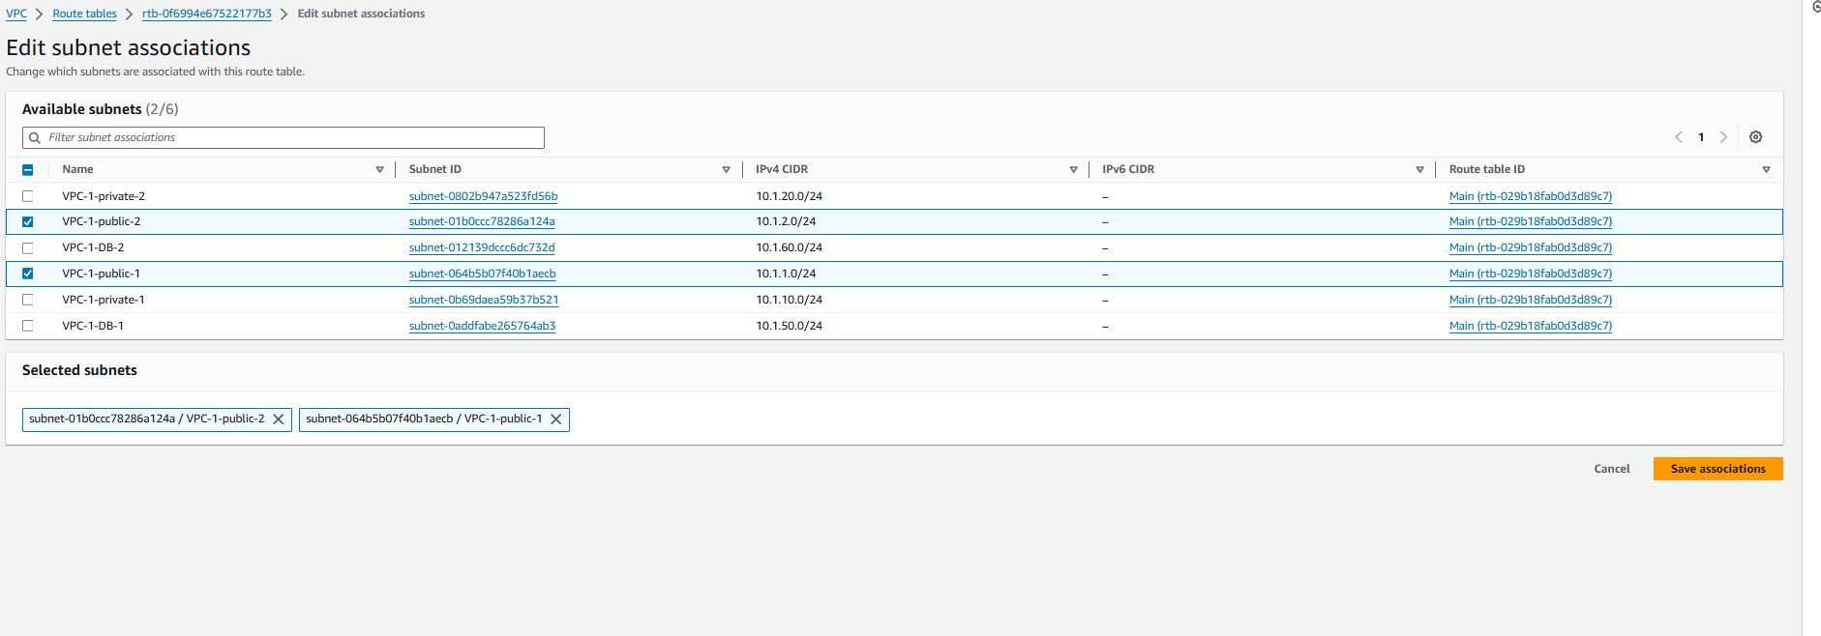

20-Like add Remaing two tables add private into private subnets and DB into DB subnets

21-Select the VPC-1-Public select the click on route add intent gateway

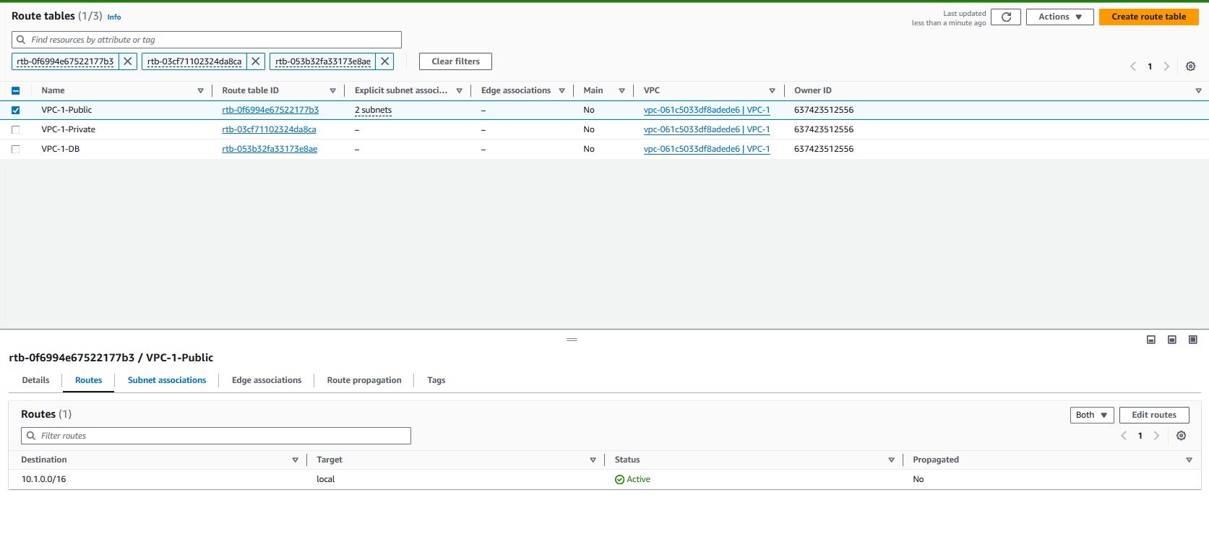

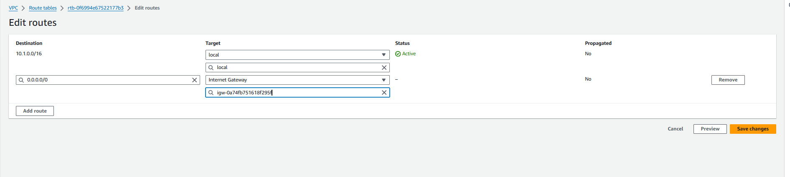

21-Create Two Nat-Gateways

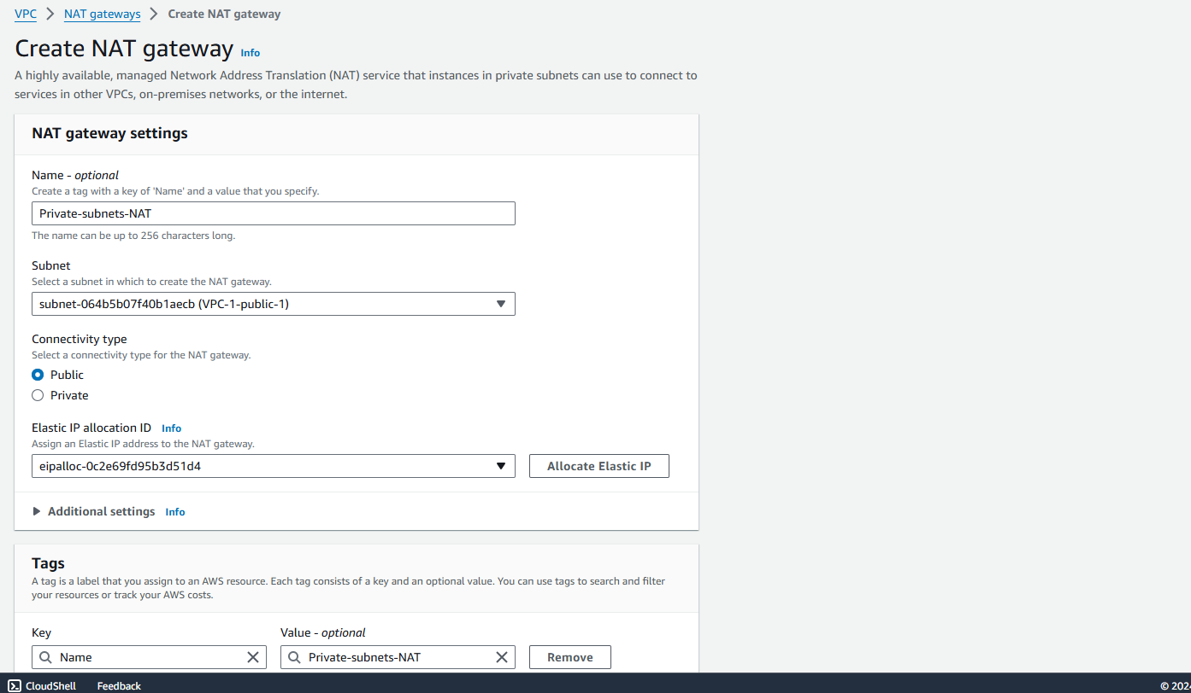

22-Like one more Create

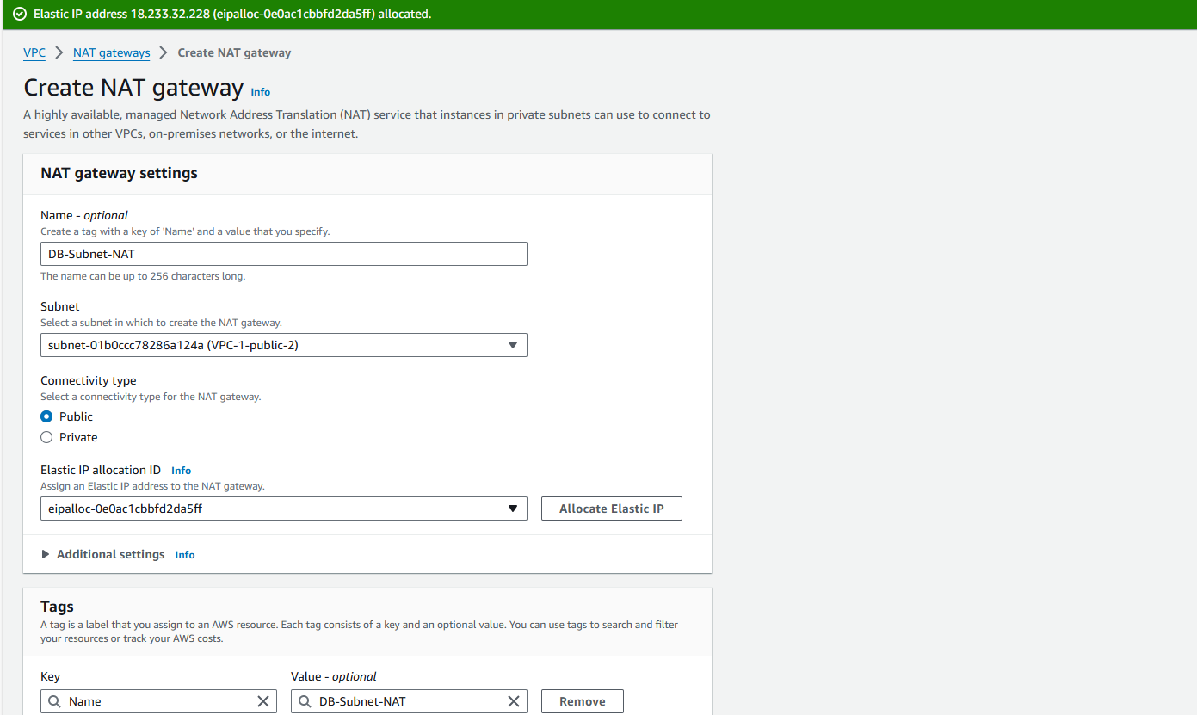

23-Click on VPC-1-Private Seletc the Route add NAt-Gateway Private-Subnet-NAT

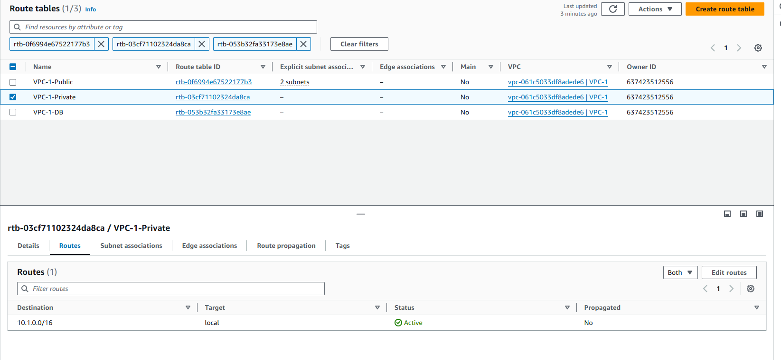

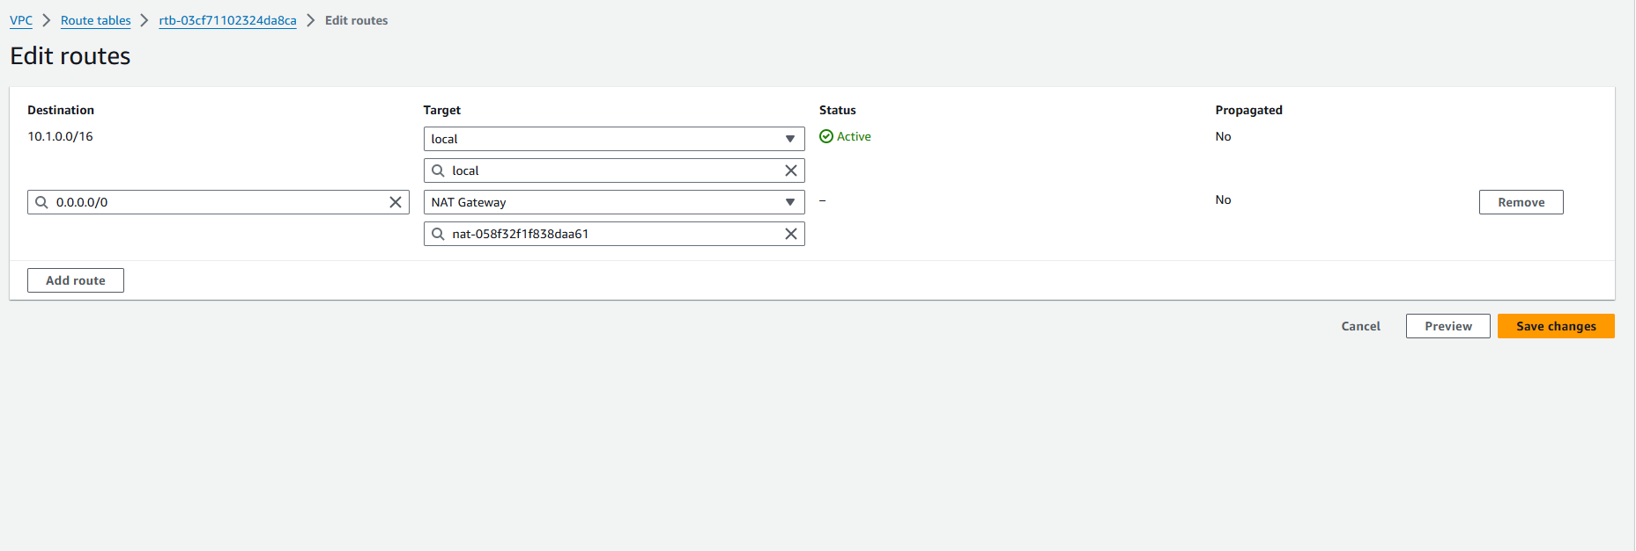

23-Like VPC-1-DB click on Route add DB-Subnet-NAT

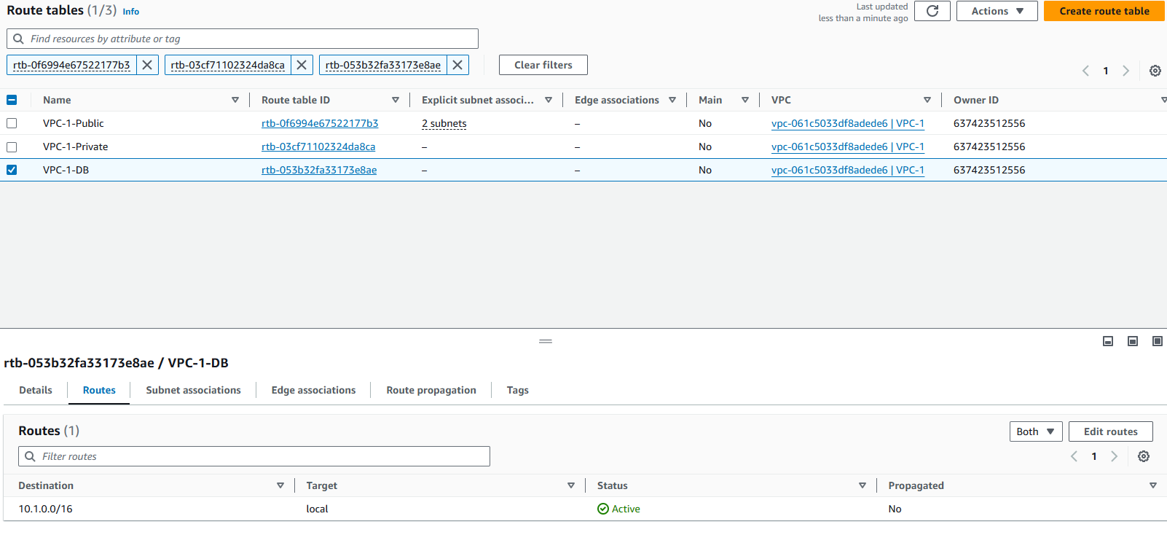

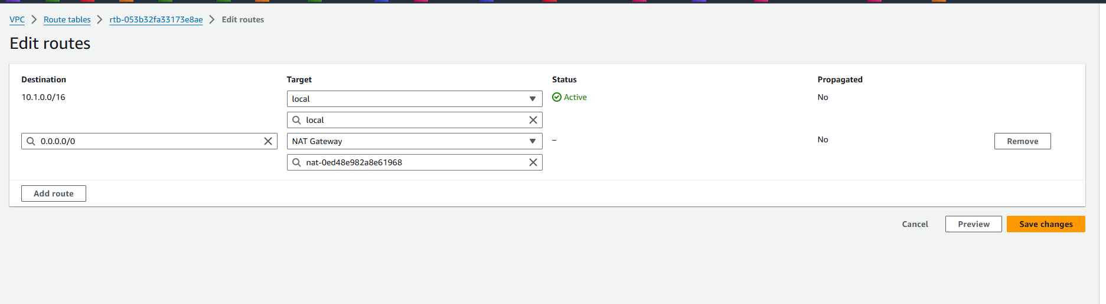

Now you can see the Full VPC Diagram

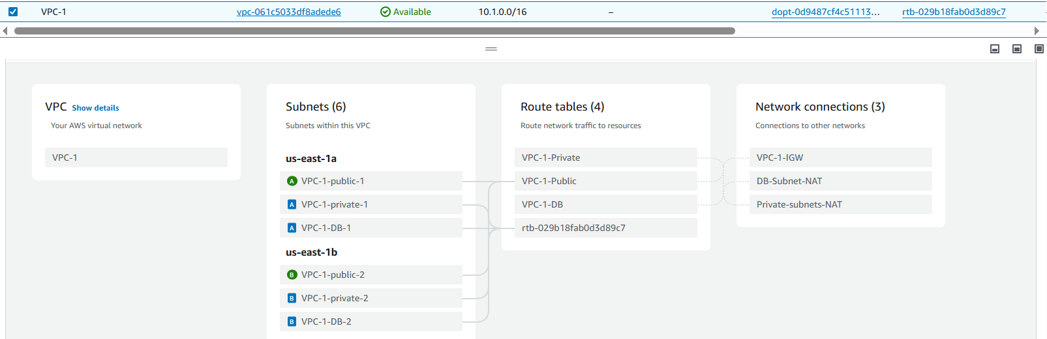

If you want Public IP whenever you want to launch the server you can select the subnets do this

